Calibrating an Accelerometer and 5kg Load Cell

Andy Perez

MAE 334 L1

Monday 2-4:20 pm

TA: Junhee Lee

Other students in Group: Andrew Alegria

Lab 2

Instrument Calibration

1. Abstract

The Purpose of this report was to calibrate an accelerometer and a load cell. Included in this purpose was the process of taking the signal captured by a computer and turning it into a useful measurement. The data presented in this lab report for part 1 are the angles made when using an accelerometer on a jig, the acceleration the accelerometer has because of those angles and gravity, and the Count Average for each angle. There are also plots of the Count Average vs angle, acceleration vs Count Average with a trend line that displays the equation for this plot, and acceleration vs time for data recorded while moving the accelerometer up and down. Then the range of the accelerometer used is determined. For part 2 a standard deviation and average Voltage is calculated for different loads. Then plots include average Voltage vs Load with a trend line with an equation for the plot, a standard deviation vs load, and Voltage vs time for 5 different cutoff frequencies for a lowpassfilter. Then a standard deviation is tabulated for five different runs with different cutoff frequencies. Finally a plot of run vs standard deviation for each cutoff frequency for the low pass filter is shown. The conclusion drawn are

1. Introduction

This study was performed to better understand the inputs that are used to calibrate instruments. There were known facts when it came to this experiment such as the error that could propagate with the accelerometer and the load cell just by moving them and or touching them while data was being recorded. It was alos known that the accelaeration in the direction was 9.81 m/s^2 *sin(angle). It was known that acceleration vs time would look like a sinusoidal curve. It was known that low pass filters filter high frequencies out. The specifications of the load cell were known including the highest load it can handle and what contributes to its output when it is overloaded. The specific purpose of the study was to calibrate an accelerometer, calibrate a load cell, and to get outputs for a low pass filter. The general ideas was to learn more about calibrating instruments, and the trends that tend to show up with them.

1. Experimental Methods

The materials used were a jig, an accelerometer, a 5kg load cell, an Arduino, a Load cell Circuit, wires, decade boxes, a ruler and a desktop computer. The first part of the lab involved adjusting the jog to 11 different angles and mounting the accelerometer on, connecting it to the Arduino for the GND, 5 Volts, and Analog in A0, A1, And A2. A ruler is used to measure the height and length of the setup for each of the 11 angles. The Arduino is plugged into the desktop, then a program is run in Arduino and a count average in the x direction is recorded out of 5 seconds for each different angle. The instrument calibrated for lab 1 is an accelerometer as shown below.

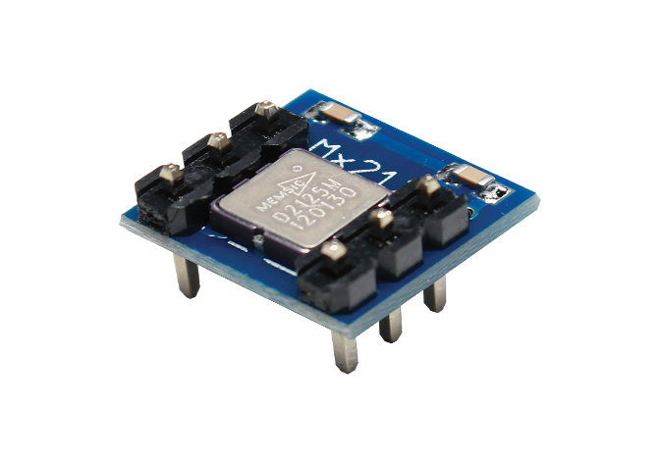

The second part of the lab involves wiring the Load cell to the Load cell Circuit, the red and black wire of the load cell are hooked up to the battery for the voltage input. The rest of its wires are hooked up to output the signal Voltage from the load cell. The load circuit cell is hooked up to the data acquisition board to connect to the desktop computer. The LabVIEW program is the opened up on the desktop computer and the Sampling Rate is set 1000 for 1 kHz and +-5 Voltage range is used. The program is run for loads on the load cell of nine different loads; the data of Voltage outputs for each load is saved.The instrument calibrate dis the load cell as shown below.

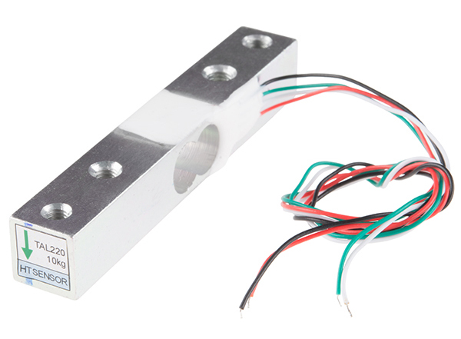

Then any loads on the load cell are removed and on LabVIEW the Sampling Rate is changed to 5000 and the range is changed to +- 1 V. The potentiometer on the Load cell circuit is adjusted to get the output Voltage close to zero. Two seconds of unfiltered data are then recorded. After the decade, boxes are used to create a low pass filter. This low pass filter is a Resistance Capacitor circuit, a model of which is shown below.

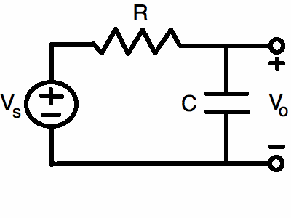

The capacitance is set to 1.59 microfarads and the resistance is set to 100 ohms, the cutoff frequency for this is 1000 Hz, and 2 seconds of data are recorded for this setup. This repeated for three more different Resistances 1, 10 and 100 kilo ohms with respective cutoff frequencies of 100, 10 and 1 Hertz. That is the procedure for part two. The entirety of the lab was done in a lab on the sixth floor of Furnas Hall at the University at Buffalo on a Monday during 2:00-4:20 pm.

1. Results

%MAE 334 lab 2  
load 'mae334'  
load 'maee334'  
load 'updown'  
load 'l'  
load 'hunk'  
load 'mae334lowpass'  
load 'mae334lowpass1'  
load 'mae334lowpass1k'  
load 'tenk'  
load 'mae334part6'  
load 'lab2redo'  
load 'ad'  
  
n=260:1:400;  
m=[ n n n n n n n n n n n n n n n n n];  
m2=size(m);  
mt=m2(2);  
 ca=accelerometerdata(:,2);  
% car=maee334(1,:);  
 angle=accelerometerdata(:,1);  
a=-9.81*sin(angle*3.14/180);  
 figure  
plot(angle,ca)  
 title('count average vs angle')  
 xlabel('angle(degrees)')  
 ylabel('count average')  
  
 figure  
plot(ca,a)  
title('count average vs acceleration')  
 ylabel('acceleration')  
 xlabel('count average')  
 legend('-.15x+49')  
  
  
  
 aud=(-0.15*m)+49;  
 t2=0:5/(mt-1):5;  
figure  
 plot(t2,aud)  
  
 ylim([-20 20])  
 title('acceleration v time')  
ylabel('acceleration')  
xlabel('time(seconds)')  
% ca=mae334duh1(1,:);  
% car=maee334(1,:);  
% angle=mae334duh1(2,:);  
% a=maee334(2,:);  
% figure  
% plot(angle,ca)  
% title('count average vs angle')  
% xlabel('angle(degrees)')  
% ylabel('count average')  
%  
% figure  
% plot(car,a)  
% title('count average vs acceleration')  
% ylabel('acceleration')  
% xlabel('count average')  
% legend('y=-0.087*x+29')  
%  
%  
% aud=(-0.087*updown')+29;  
% t=0:5/75:5;  
% figure  
% plot(t,aud)  
% title('acceleration v time')  
% ylabel('acceleration')  
% xlabel('time(seconds)')  
  
vave=lab2mae334part1(1,:);  
lod=lab2mae334part1(2,:);  
sd=lab2mae334part1(3,:);  
figure  
plot(lod,vave)  
title('vave v load')  
ylabel('vave(Volts)')  
xlabel('load(grams)')  
legend('y=.00096x+.033')  
  
figure  
plot(lod,sd)  
title('standard deviation v load')  
ylabel('standard deviation')  
xlabel('load(grams)')  
  
%loadredo=lab2redo(1,:);  
%vaveredo=lab2redo(2,:);  
%sdredo=lab2redo(3,:);  
%figure  
%plot(loadredo,vaveredo)  
%figure  
%plot(loadredo,sdredo)  
  
  
t=1:1:5000;  
figure  
plot(t,mae334lowpass)  
ylim([-.03 9*10^-4])  
title('unfiltered')  
ylabel('voltage')  
xlabel('time(seconds)')  
  
figure  
plot(t,MAE334lowpass1)  
title('lowpass')  
ylim([-.03 9*10^-4])  
ylabel('voltage')  
xlabel('time(seconds)')  
  
figure  
plot(t,MAE334lowpass1k)  
ylim([-.03 9*10^-4])  
title('1 kiloohm')  
ylabel('voltage')  
xlabel('time(seconds)')  
  
figure  
plot(t,tenk)  
ylim([-.03 9*10^-4])  
title('10 kohm')  
ylabel('voltage')  
xlabel('time(seconds)')  
  
figure  
plot(t,hunk)  
ylim([-.03 9*10^-4])  
title('100 kohm')  
ylabel('voltage')  
xlabel('time(seconds)')  
  
n=mae334part6(:,2);  
sdn=mae334part6(:,1);  
figure  
plot(n,sdn)  
title('sd vs #')  
ylabel('standard deviation')  
xlabel('trial run #')

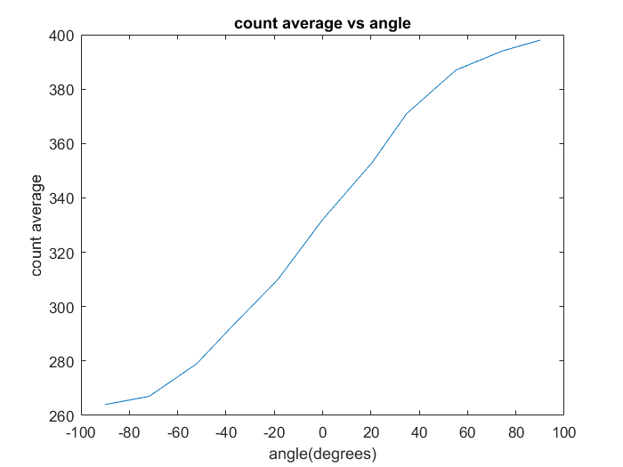

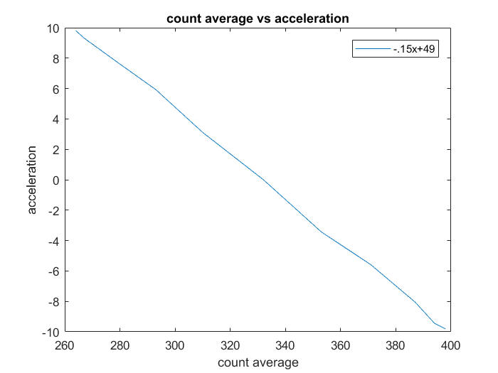

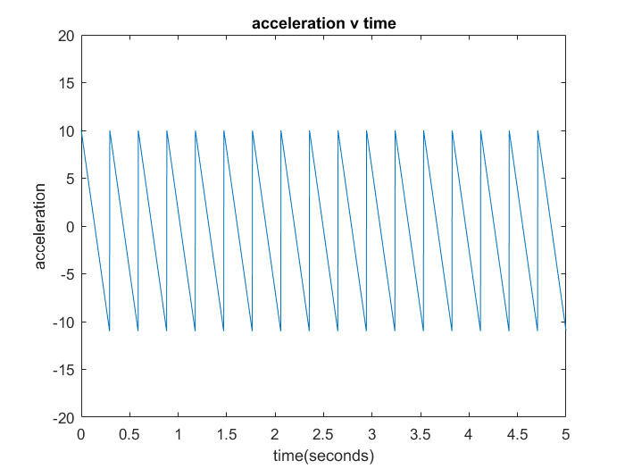

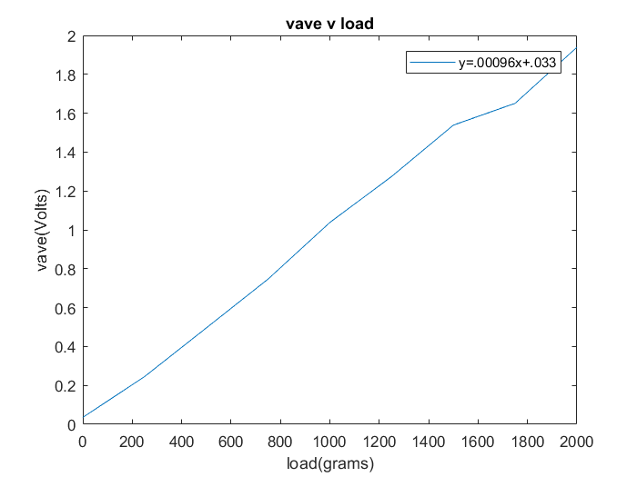

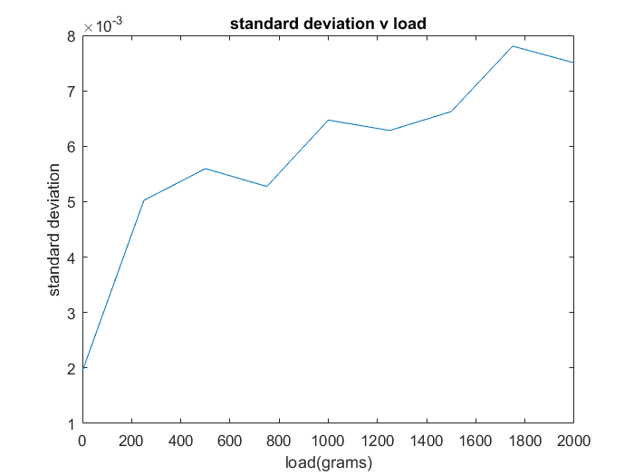

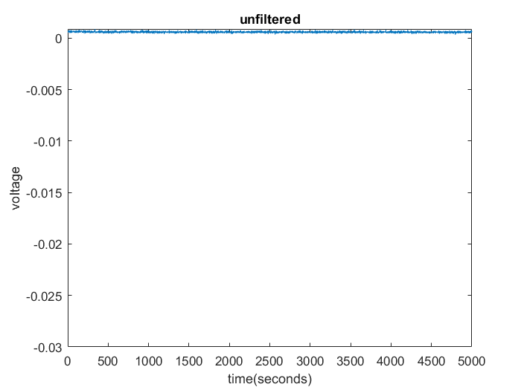

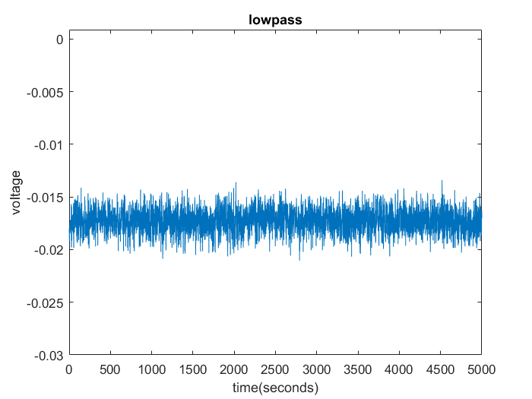

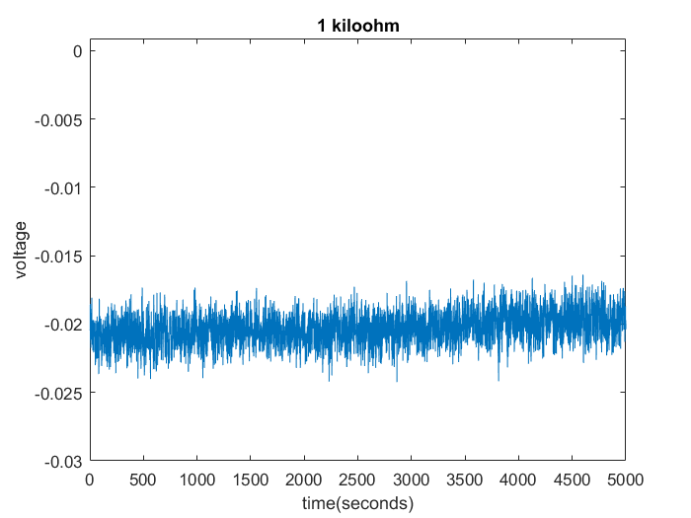

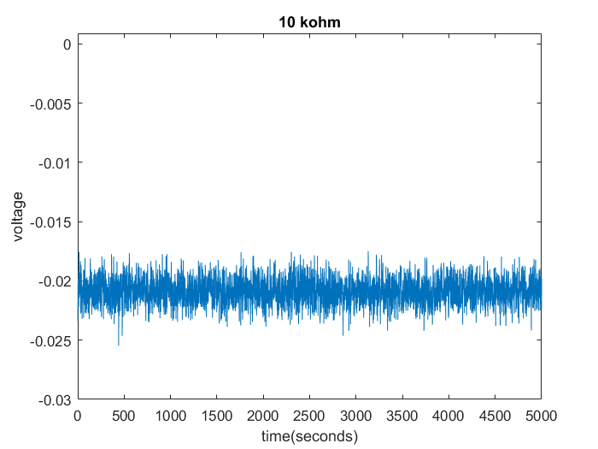

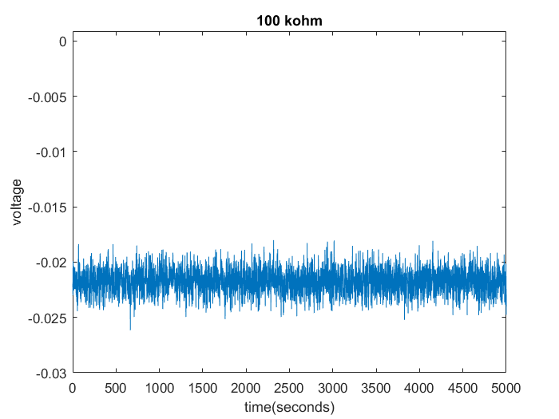

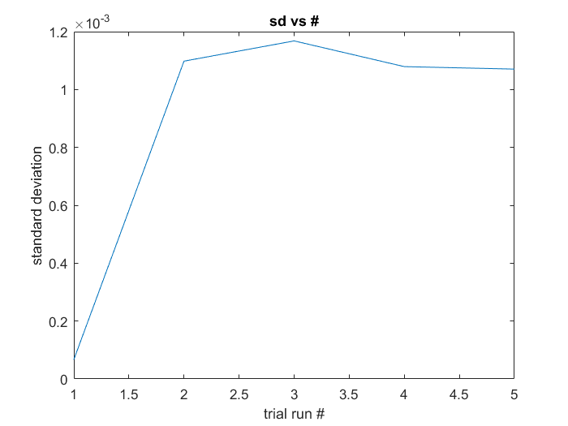

*Pu*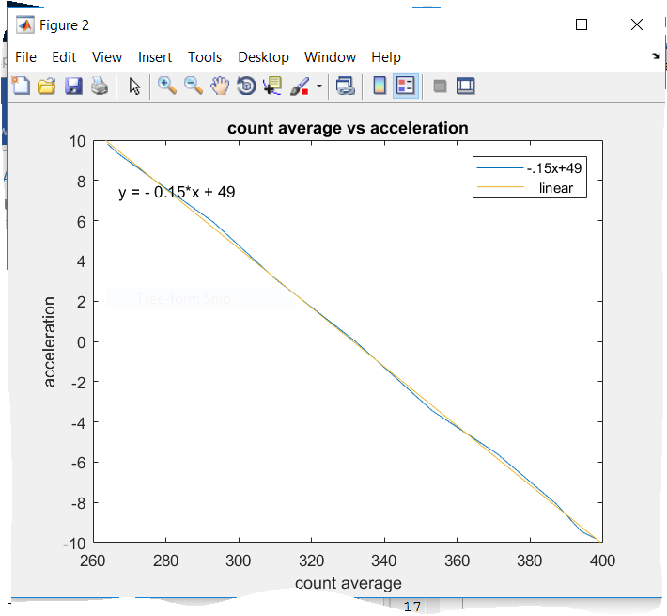

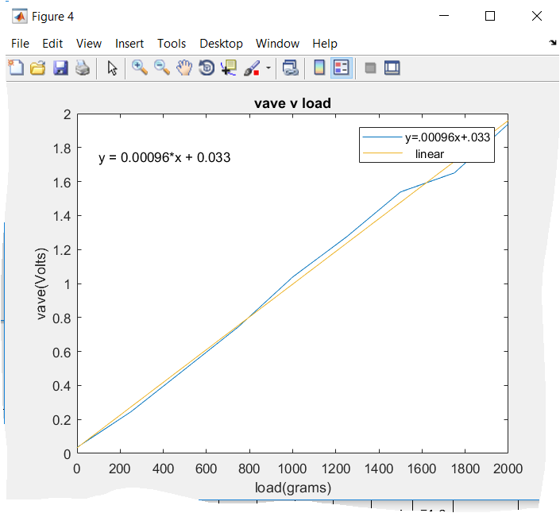

Above is the trend line graphs.

|  |  |  |  |  |  |  |  |  |  |  |  |  |
| --- | --- | --- | --- | --- | --- | --- | --- | --- | --- | --- | --- | --- |
|  | 0 | 1 | 2 | 3 | 4 | 90 | -1 | -2 | -3 | -4 | 180 | Up-down |
| Count Average | 332 | 353 | 371 | 387 | 394 | 398 | 310 | 293 | 279 | 267 | 264 | 349.0395 |
| angle | 0 | 20.5 | 34.8 | 55.2 | 74.3 | 90 | -18.5 | -37.2 | -52.1 | -71.8 | -90 |  |
| acceleration | 0 | -3.43 | -5.59 | -8.05 | -9.44 | -9.81 | 3.11 | 5.93 | 7.73 | 9.32 | 5.439176 |

|  |  |  |
| --- | --- | --- |
| run | f | sd |
| 1 | not filtered | 6.68E-05 |
| 2 | 1000 | 0.001098 |
| 3 | 100 | 0.001168 |
| 4 | 10 | 0.001079 |
| 5 | 1 | 0.001071 |

The range of my accelerometer is between -10g’s and 5 g’s.

Lab Report Discussion: 1) Why wouldn’t we want to use the Count Average vs. Angle for our calibration? The reason we use acceleration vs count average instead of count average vs angle is because if we used Count Average vs angle then we would get no linear relationship for angle vs time. There is no linear relationship between angle and time the only time angles can be substituted for the sin of them is when they are very small.

2) What could be done to improve the accuracy of the calibration?

In order to improve the accuracy of the calibration then the mounted accelerometer could be better fixed, that way it is not affected whenever a person goes to change the mount, or leave room for a person shaking the table that the mount is on. Also in the lab instead of using the ruler, a protractor could be used to get the angle in order to get a more accurate measure.

1. What would you expect to happen if you exceeded the maximum load of 5 kg?

1) If the maximum load of 5 kg is exceeded then I would expect the load cell material to plastically deform and it would not be able to return to its original shape. I also expect to see a signal offset leading to the inevitability that the load cell can no longer be calibrated as referenced in [2].

2) What is the maximum voltage you would expect to measure for this load cell? Discuss how you determined this value.

1. The maximum voltage that I would expect to measure for this load cell is 5.793 volts. I determined this value from the relationship I got from the trend line equation I found in plotting the average voltage with respect to the load. The safe overload referenced in [1] “is 120 % capacity, the safe overload is the load that can be applied without producing a permanent shift in characteristics beyond those specified”. This means no changes will happen after the safe overload is applied including the maximum Voltage. The safe overload is 120% of 5 kg, which is 6kg, and then I used the 6 kg as 6000 grams in the trend line equation and got a result of 5.793 volts. While this is an average Voltage, it is a good indicator of the maximum Voltage.

3) Discuss any trends that you see in the standard deviation vs. load plot (Results- Step 3) as well as the possible causes for the trend. Other than filtering, what could be done to correct these issues?

3) The trends that are apparent in the standard deviation vs. load plot are the overall increase of standard deviation as the load increases, and that at every interval of applying a new load the slope changes sign, from positive to negative and vice-versa. In order to correct these issues there could be a better control environment to load the load cell in.

4) What trends do you see in the standard deviation for different filter cutoff frequencies?

4) The trend of the graph shows that the slope always changes at the filter cutoff frequencies. The slope is positive until the third filter cutoff frequency, which is 100 Hz, and then the slope starts trending downward.

5) Discuss the advantages and disadvantages of using a low-pass filter for a measurement.

The advantages of a low pass filter are that it omits high frequencies, without effecting the measurement. Usually a high sampling rate is needed, but that comes with high frequencies that re not needed and the low pass filter does not consider them as referenced in [3]. The disadvantage that comes with using a low pass filter is the higher speed digital circuits needed to use it.

Citations

[1] <https://ublearns.buffalo.edu/bbcswebdav/pid-4068779-dt-content-rid-14977930_1/courses/2171_17359_COMB/Micro%20Load%20Cell%20CZL635.pdf>

[2]<https://static1.squarespace.com/static/55c259cbe4b01d3131893195/t/55c89e97e4b05a3c92050fbd/1444751606008/Load-Cells-Overloaded.pdf>

[3] <http://www.mstarlabs.com/dsp/antialiasing/antial.html>

*blished with MATLAB® R2017a*